Lab # 01
MS WORD
Objective: Exploring I/O Devices through Word Processing using Microsoft Word & Exploring its Features Hyperlinks, References Captions & Using Mail merge.

Introduction
Microsoft Word is a word processor developed by Microsoft and it was first released in 1983.A full-featured word processing program for Windows and Mac OS X from Microsoft. Available stand-alone or as part of the Microsoft Office suite. Word files are commonly used as the format for sending text documents via e-mail because almost every user with a computer can read a Word document by using the Word application, a Word viewer or a word processor that imports the Word format.
Microsoft Word is a popular word-processing program used for creating documents such as letters, brochures, learning activities, tests, quizzes and students' homework assignments. There are many powerful features available in Microsoft Word to make it easier to learn for students with disabilities.
Input device
An input device can send data to another device, but it cannot receive data from another device. Examples of an input device include a computer keyboard and mouse, which can send data (input) to the computer, but they cannot receive or reproduce information (output) from the computer.
Output device
An output device can receive data from another device, but it cannot send data to another device. Examples of an output device include a computer monitor, projector, and speakers, which can receive data (output) from the computer, but they cannot send information (input) to the computer.
I/O device
Depending on the interaction, a device can be both, referred to as an input/output or I/O device. An input/output device can send data to another device and also receive data from another device. Examples of an input/output include a computer CD-RW drive and USB flash drive which can send data (input) to a computer and also receive data (output) from a computer.

Text Boxes
A text box is a moveable field where you can enter text and apply formatting to that text that does not apply to or affect the rest of your document.
Step 1: Place your cursor wherever you wish to insert the text box into your document. Click the “Text Box” dropdown menu in the Text group within the Insert Tab.
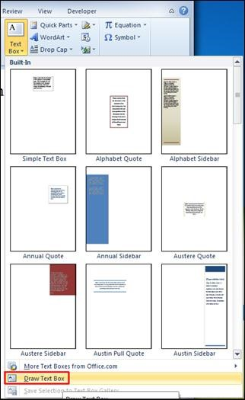
Step 2: As you can see, there is a variety of options available, the most common of which is “Simple Text Box.” If you select this option, a textbox like the one below will appear in your document:

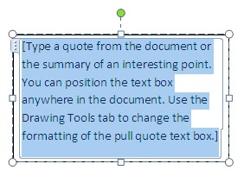


“Show me a hero and I can write you
a tragedy.”
–
F. Scott Fitzgerald

Example of a textbox when
you write in it.

Step 3: Once you have inserted your text box, you can resize it, move it around within your document, and format the interior text according to your preferences.

Fancy Textboxes and Pictures with Text
To position the textbox within the picture is really the same thing, except you may find that the simple textbox might just be that…too simple for the picture you want to use (especially if you’re handing it in and a publisher, employer, whoever wants a clean looking, fancy presentation).
Step 1: select the picture you want to use. For example, the picture below is something I’d be using for a book on the ethics of animal care.


To insert the textbox, you would repeat the same process that you used for the simple textbox. However, you’d choose a fancier one (for this I am going to use Austere, which can be seen on the next page):
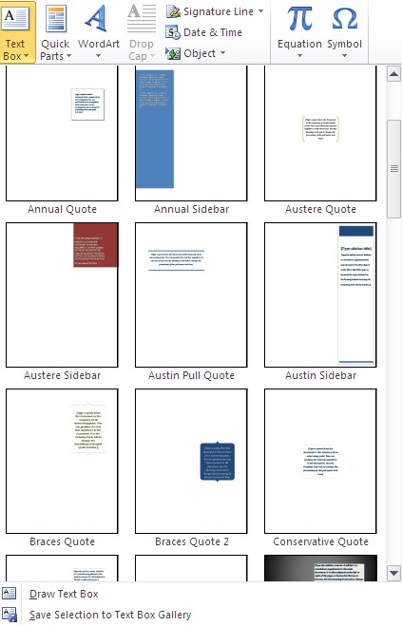

Then insert the austere textbox on or below the photo (depending which looks better) as seen below (both options):



Final Words about Textboxes
If you don’t want a border around the textbox, especially for pictures, to get rid of the border is simple. First, when you insert a textbox, you will get an option like this:
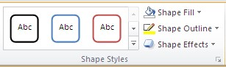

Click here

Scroll down the “no fill” option and you will be good to go!

Watermarks
A watermark is a faded stamp that appears in the background of your document. This function can be very useful if you wish to brand your document with a message that sets it apart from an everyday piece of paper. For example, messages like “SAMPLE,” “DO NOT COPY,” “CONFIDENTIAL” etc. can all be made immediately noticeable by putting them on the document as a watermark.
Step 1: Click on the Watermark dropdown menu in the Page Background group of the Page Layout Tab.
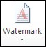
Here you will see a variety of options for ready-made watermarks that Microsoft Word has provided for you.
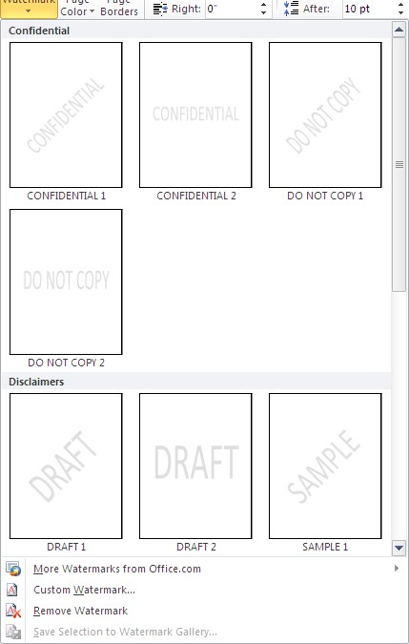

Step 2: If you do not wish to apply one of these ready-made watermarks, you also have the option of creating a custom watermark. You can do this by clicking Custom Watermark… at the bottom of the dropdown menu.
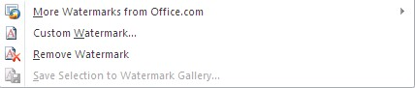

Clicking this will open the custom watermark dialogue box.

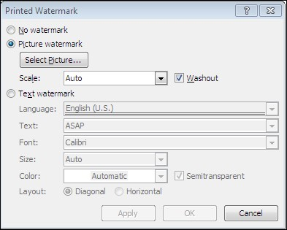
Step 3. This dialogue box will allow you to enter specific, custom text as your watermark, or even to insert an image as your watermark. For example, if you are writing a letter or flyer around a certain holiday, you can insert a holiday appropriate image that will lay washed out in the background of your text. Example below:

Keep in mind that you MUST have whatever picture you’re going to use already saved on your hard drive. You CANNOT use clipart. However, if you do want clipart, visit the Microsoft website and you can download the clipart to save on your hard drive.

Page Borders
Word allows you to apply a border to your document, to create a professional or a decorative look. To do so, click Page Borders in the Page Background group of the Page Layout tab. When you do this, the Borders and Shading dialogue box will appear. (Pictured below:)

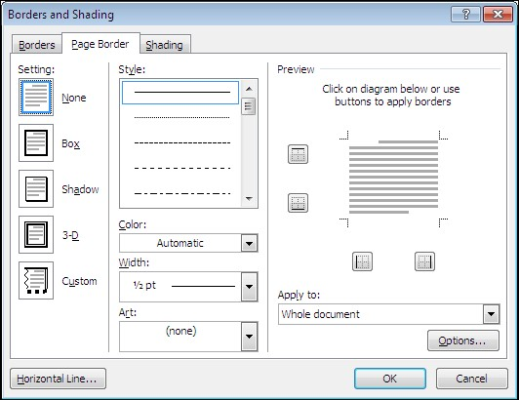
This box allows you to play with various border options and adjust them to your needs. There are simple line options, shadowing options, and options for more intricate border designs, which you can find in the Art dropdown menu.
The Preview area of this box allows you to see how your document will look with the borders in place. If you only wish to apply a border to certain sides of the document, you can adjust this by clicking the four square buttons in the Preview area.

Inserting Hyperlinks
This function allows you to insert a hyperlink into your document. This is useful because rather than having to copy and paste a website address from the document into your web browser, you and whoever else accesses your document will be able to click the link in the document and immediately open the website.
Step 1: Select the “Hyperlinks” button in the Links group.
Step 2: A dialogue box will appear with several options for how to insert your hyperlink. You can select something from a folder, select a website address from a list of your recently browsed websites, or select a recent file.
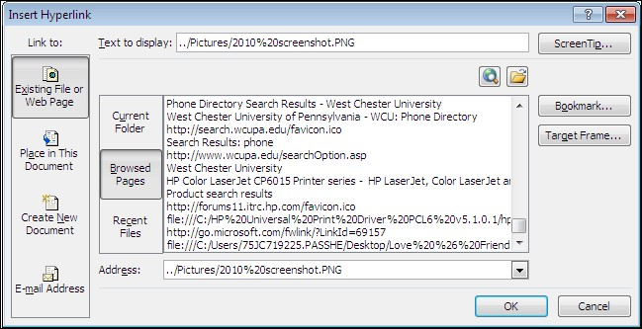
Step 3: If you want to simply manually type in the website address that you would like to link to, then you may do so by typing it next to “Address:” in the dialogue box.
Step 4: If you would like the link to appear as something other than the website address, then simply type a title or display text next to “Text to display:” at the top of the dialogue box. For example, if the website address that you selected to insert is “http://www.facebook.com”, but you only want the link to appear as “Facebook” then you would just type “Facebook” into the “Text to display:” space before clicking OK.

Captions
Almost like the textboxes, captions are used to label a picture, chart or whatever else you will need to label. However, unlike textboxes, it will only be labeled as “figure,” “table,” or “equation” like in the example below:

Figure 1: The Pyramid in Cairo
Step 1: Go to the Captions tab and click the icon with the document with a picture on it.
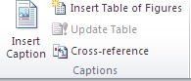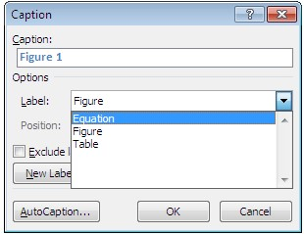

Step 2:

You will be brought to a dialogue
box and will be given options of figure,
table or equation. Pick whatever suits
your needs best.

Here you will be able to choose
either
the equation, figure or table label.

Here you will also be able to choose whether you want numbers, roman numerals or letters following the label.
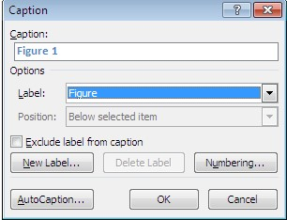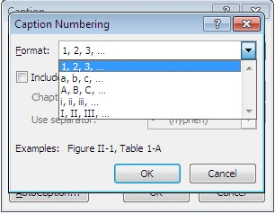

Click the numbering…
button for your options.

Here are the lists of
options
that are
available for you to use
.

Mail Merge
Step 1: Prepare data in Excel for mail merge
The most important step in the mail merge process is to set up and prepare your data. You'll use your Excel spreadsheet as the data source for the recipient list.
Here are some tips to prepare your data for a mail merge. Make sure:
Column names in your spreadsheet match the field names you want to insert in your mail merge. For example, to address readers by their first name in your document, you'll need separate columns for first and last names.
All data to be merged is present in the first sheet of your spreadsheet.
Data entries with percentages, currencies, and postal codes are correctly formatted in the spreadsheet so that Word can properly read their values.
The Excel spreadsheet to be used in the mail merge is stored on your local machine.
Changes or additions to your spreadsheet are completed before it's connected to your mail merge document in Word.
NOTES:
You can import information from your Excel spreadsheet by importing information from a comma-separated value (.csv) or a text (.txt) file and use the Text Import Wizard to build a new spreadsheet.
For more information, see Prepare your Excel data source for mail merge in Word.
Step 2: Start the mail merge
In Word, choose File > New > Blank document.
On the Mailings tab, in the Start Mail merge group, choose Start Mail Merge, and then choose the kind of merge you want to run.
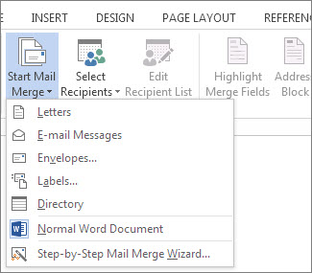
Choose Select Recipients > Use an Existing List.
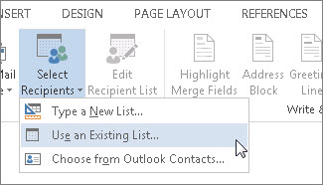
Browse to your Excel spreadsheet, and then choose Open.
If Word prompts you, choose Sheet1$ > OK.
NOTE: Now the Excel spreadsheet is connected to the mail merge document you’re creating in Word.
Edit your mailing list. You can limit who receives your mail. Choose Edit Recipient List.
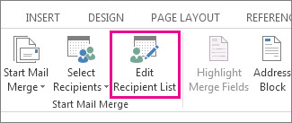
In the Mail Merge Recipients dialog box, clear the check box next to the name of any person who you don't want to receive your mailing.
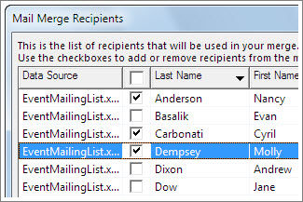
NOTE: You also can sort or filter the list to make it easier to find names and addresses. For more information about sorting and filtering items, see Sort and filter the data for a mail merge.
Step 3: Insert a merge field
You can insert one or more mail merge fields that pull the information from your spreadsheet into your document.
To insert an address block for an envelope, a label, an email message, or a letter
On the Mailings tab, in the Write & Insert Fields group, choose Address Block.
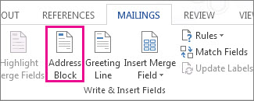
In the Insert Address Block dialog box, choose a format for the recipient's name as it will appear on the envelope.
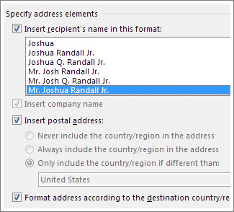
Choose OK.
Choose File > Save.
To insert a greeting line in an email message or a letter
On the Mailings tab, in the Write & Insert Fields group, choose Greeting Line.
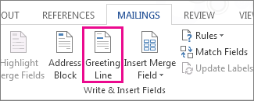
In the Insert Greeting Line dialog box, do the following:
Under Greeting line format, change the salutation if necessary by choosing the greeting (Dear is the default), the format for the recipient’s name, and the ending punctuation (a comma is the default). And Under Greeting line for invalid recipient names, choose an option in the salutation list.
Choose OK.
Choose File > Save.
To insert data from your spreadsheet in an email message or a letter. On the Mailings tab, in the Write & Insert Fields group, choose Insert Merge Field.
In the Insert Merge Field dialog box, under Fields, choose a field name (column name in your spreadsheet), and then choose Insert.
Repeat step 2 as needed, and choose Close when done.
Choose File > Save.
For more information about adding fields from your spreadsheet to the merge document, see Insert mail merge fields. And if you're interested in learning more about options for setting up email message, see Email merge in Word.
Step 4: Preview and finish the mail merge
After you insert the merge fields you want, preview the results to confirm that the content is okay. and then you're ready to complete the merge process. On the Mailings tab, choose Preview Results.
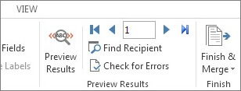
Choose the Next or Previous record button to move through records in your data source and view how the records will appear in the document. In the Finish group, choose Finish & Merge, and choose Print Documents or Send E-mail Messages.
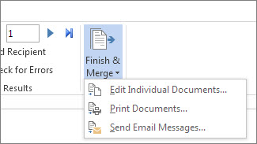
Step 5: Save your mail merge
When you save the mail merge document, it stays connected to your data source. You can reuse the mail merge document for your next bulk mailing. Open the mail merge document and choose Yes when Word prompts you to keep the connection.

Lab Tasks
Task # 01: Design following layout for input output storage devices.
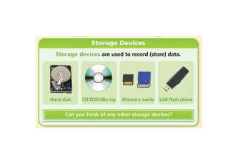
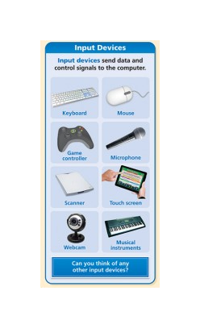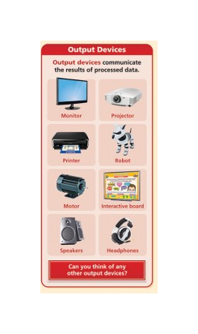
Task # 02: To create an Advertisement.

Task # 03: Draw a Pie Chart to show a percent of pc operating profit 2016 with a different color, design and percentage choice, Format data labels and legend labels.

Task # 04: Draw a Cycle process through word smart art which include your daily routine.
Task # 05: Create a word document that include following headings:
- My biography
- My best childhood memory
- My inspiration
- My favorite sports
- Where do I see myself in five years?
- My social Networking Sites/links
The following headings should include some description , pictures related to headings, Hyperlinks, table of content & table of figures should be generated in the last of the whole document

Task # 06: Apply mail merge on the following letter:
Write a congratulations letter to the employee for getting new job Add the following fields in excel form and send it to your friend.
- First Name
- Last Name
- City
- Province
- Postal
- Email
- Company Name
Your letter should look like the template given below.

